**NCTU CN2018 Lab. 1**

**– Packet Manipulation via Scapy**

Student name:陸顗文 Student ID: 0616039 Department: CS

**Part A. Questions**

1. What is your command to filter the packet with customized header on Wireshark?

tcp.seq == 2

1. Show the screenshot of filtering the packet with customized header.  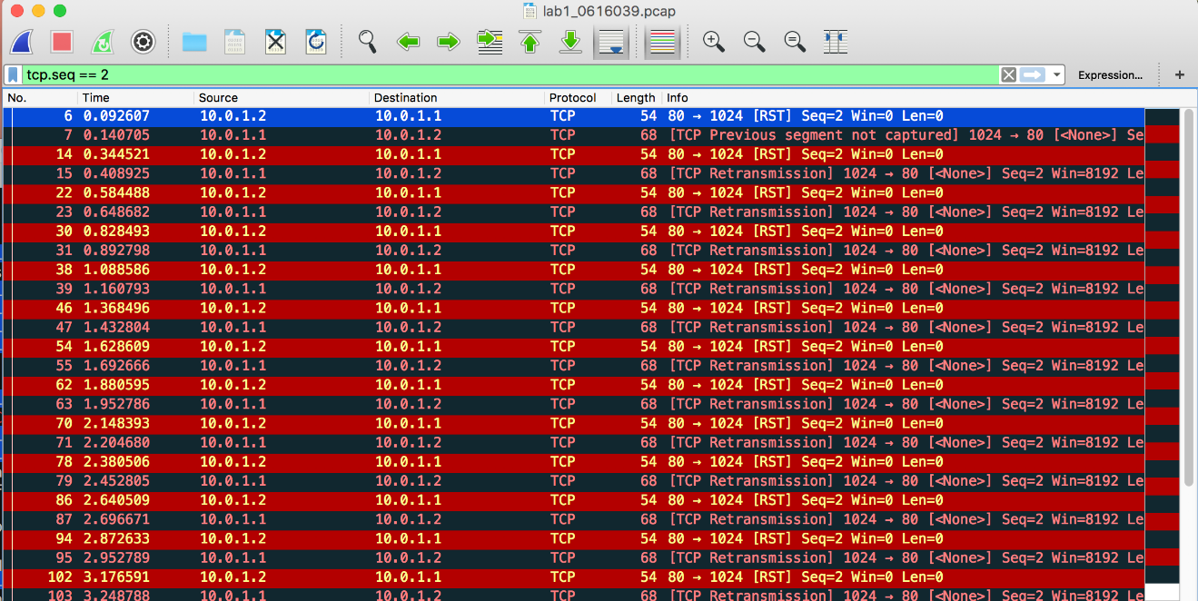
2. What is your command to filter the packet with “secret” payload on Wireshark?

tcp.seq == 3

1. Show the screenshot of filtering the packet with “secret” payload.

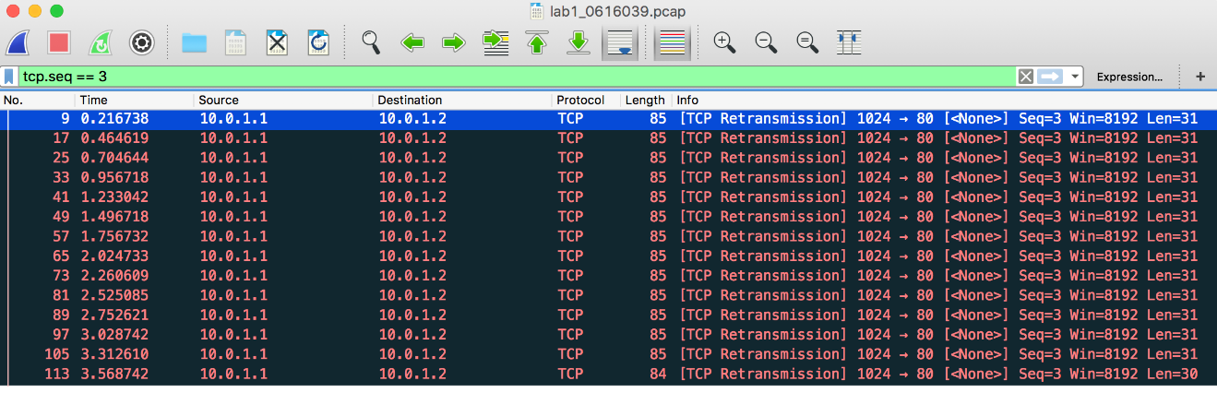

1. Show the result after decoding the “secret” payload.

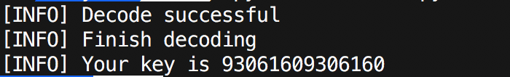

**Part B. Description**

Task 1 – Environment setup

• Download required files from GitHub

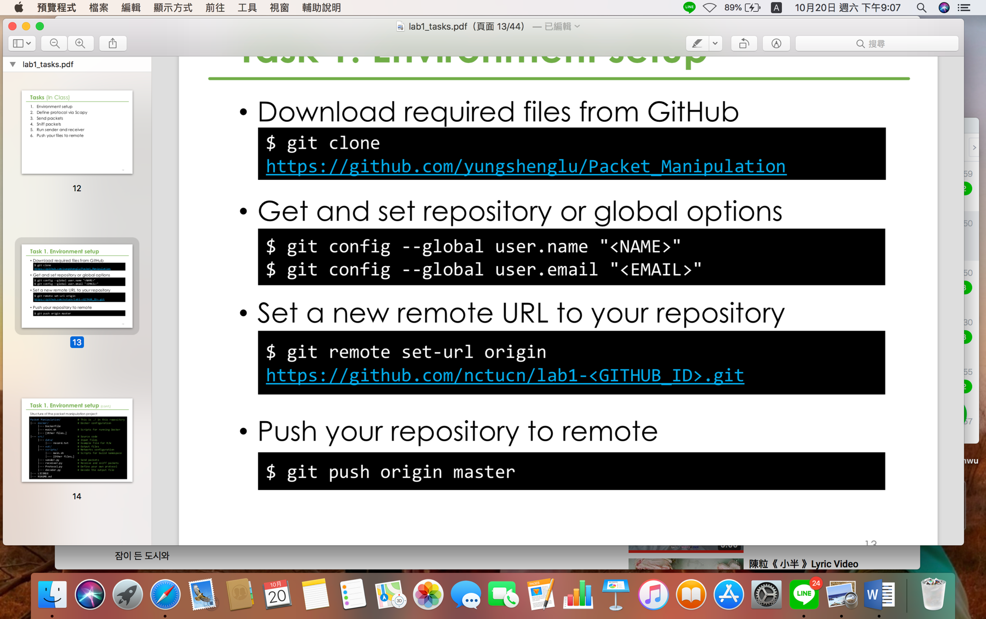

• Get and set repository or global options

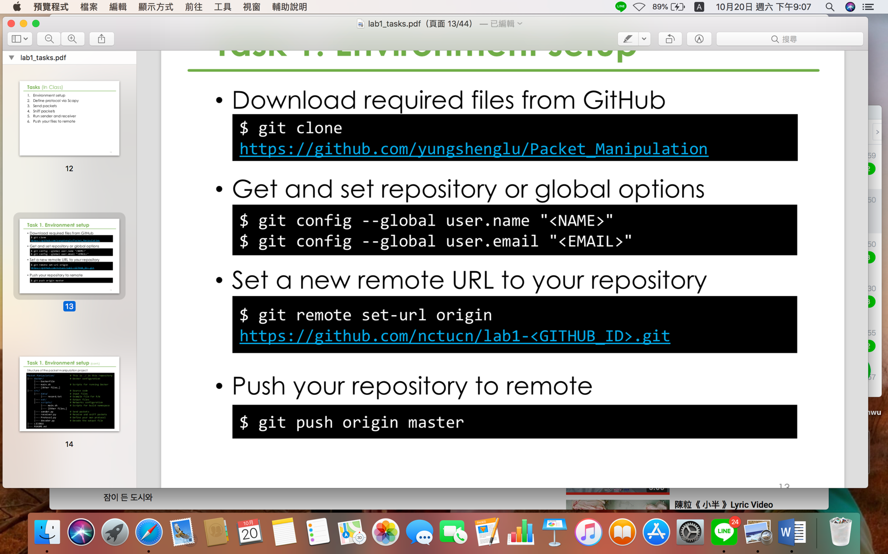

“<NAME>” 🡪 0616039

“<EMAIL>” 🡪 ivy0621.cs06@g2.nctu.edu.tw

• Set a new remote URL to my repository

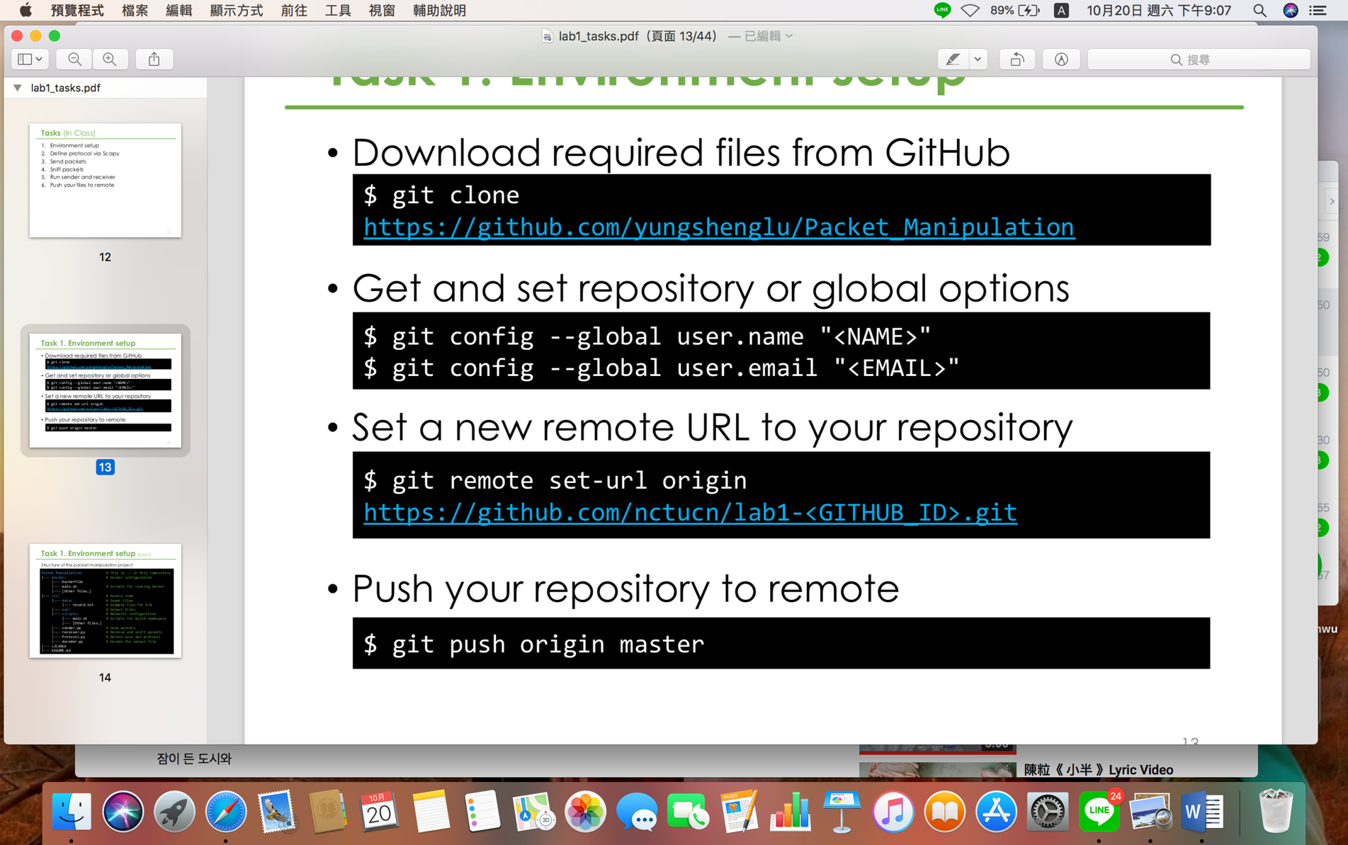

不用換行，<GITHUB_ID> 🡪 0616039

• Push my repository to remote

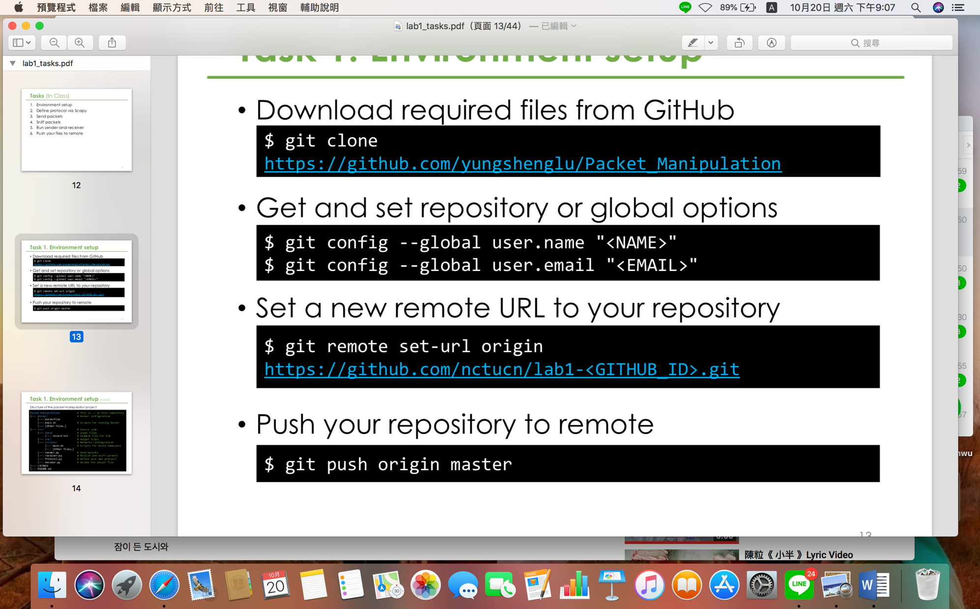

• Copy the following configuration to the Dockerfile (./docker/Dockerfile)

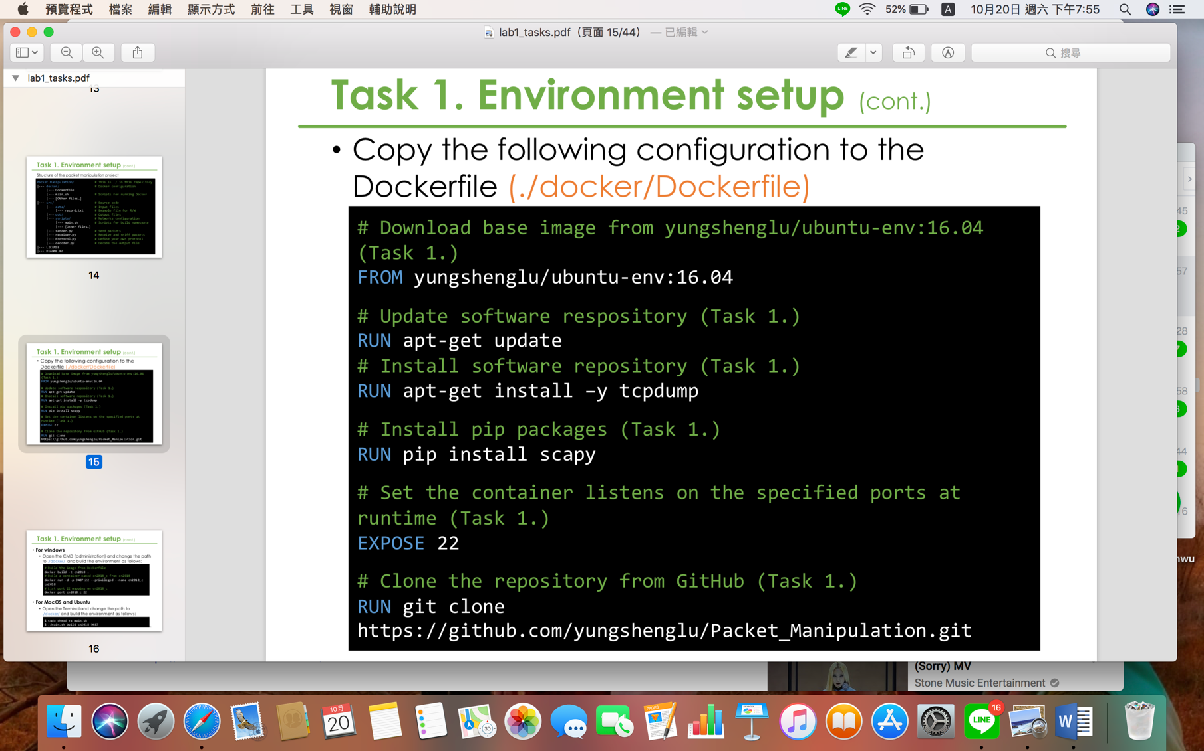

• Open the Terminal and change the path to ./docker/ and build the environment as follows:

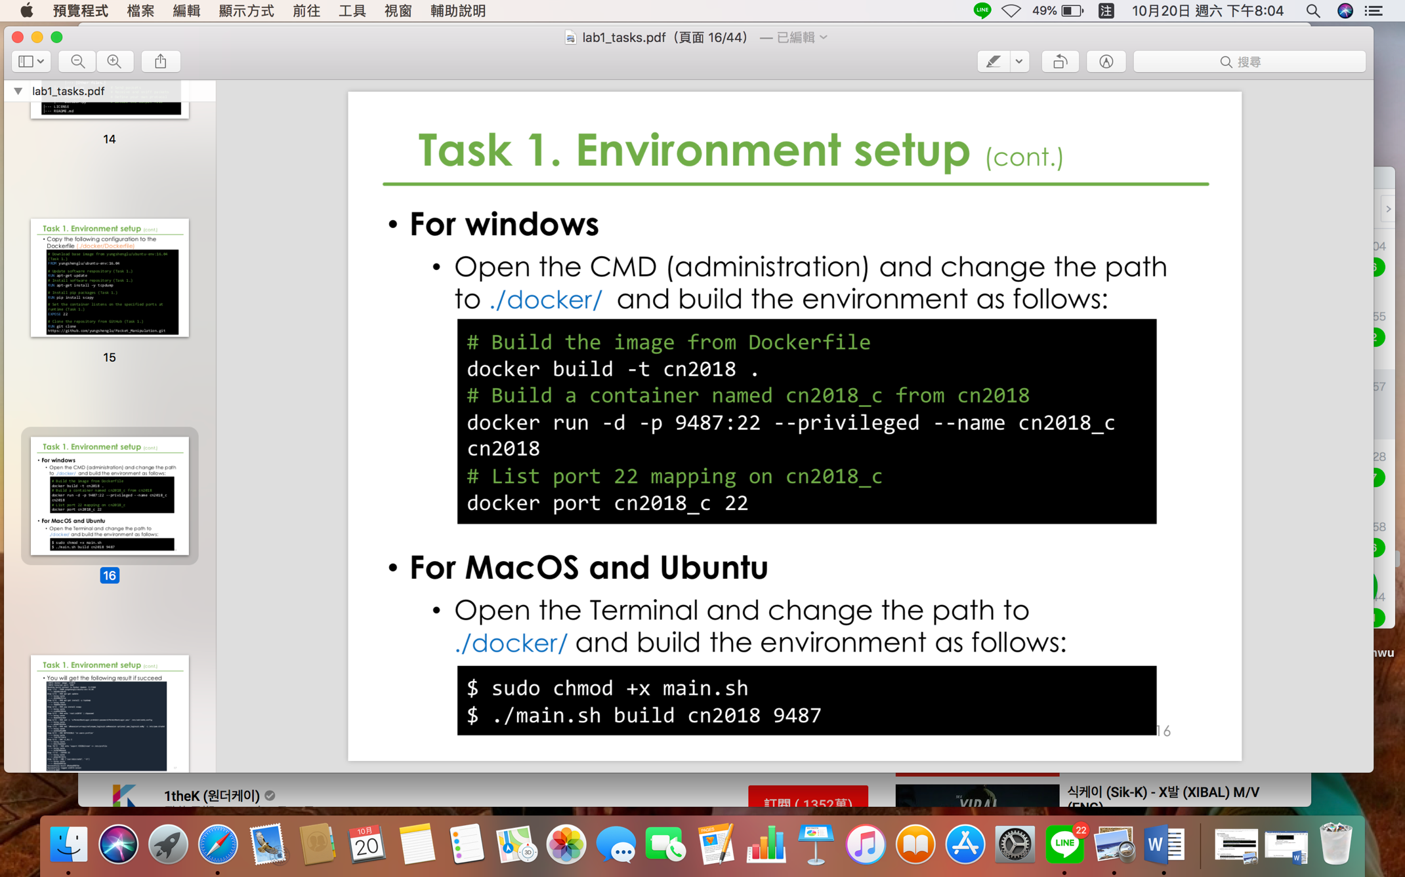

• Login to my Docker container using SSH

• Use terminal to connect to the Docker

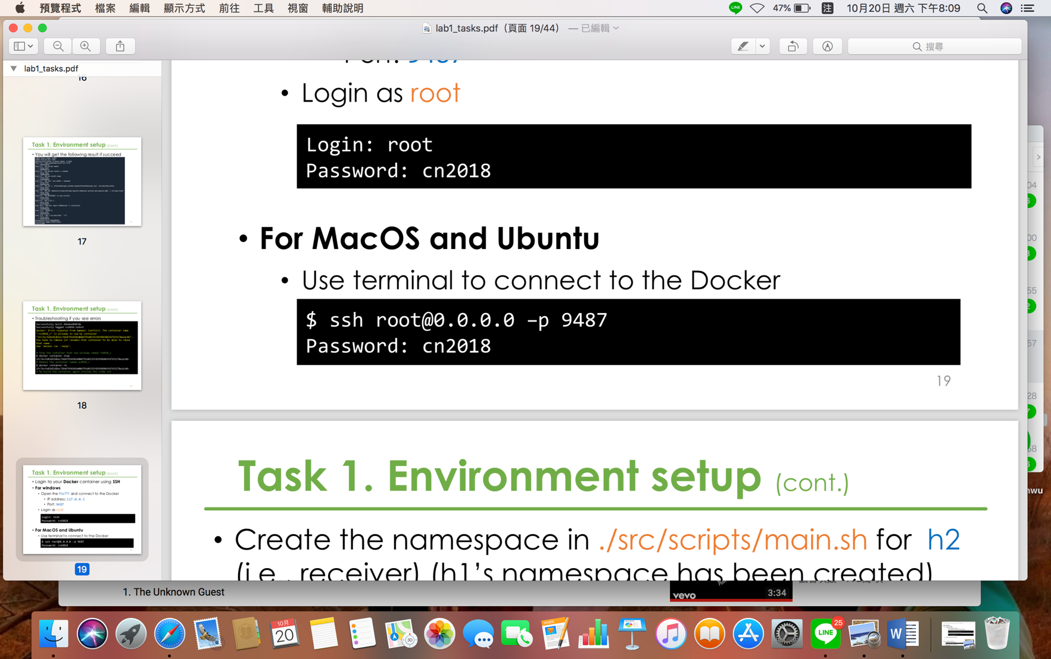

• Create the namespace in ./src/scripts/main.sh for h2

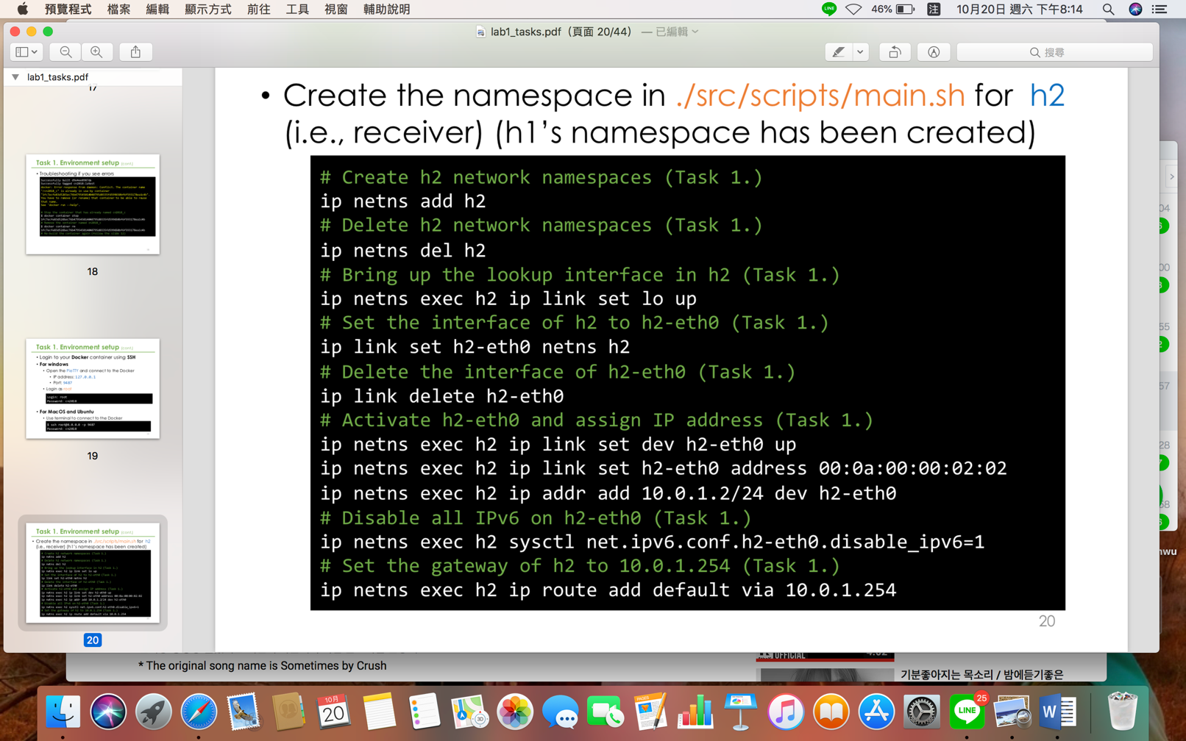

• Run main.sh to build the namespace

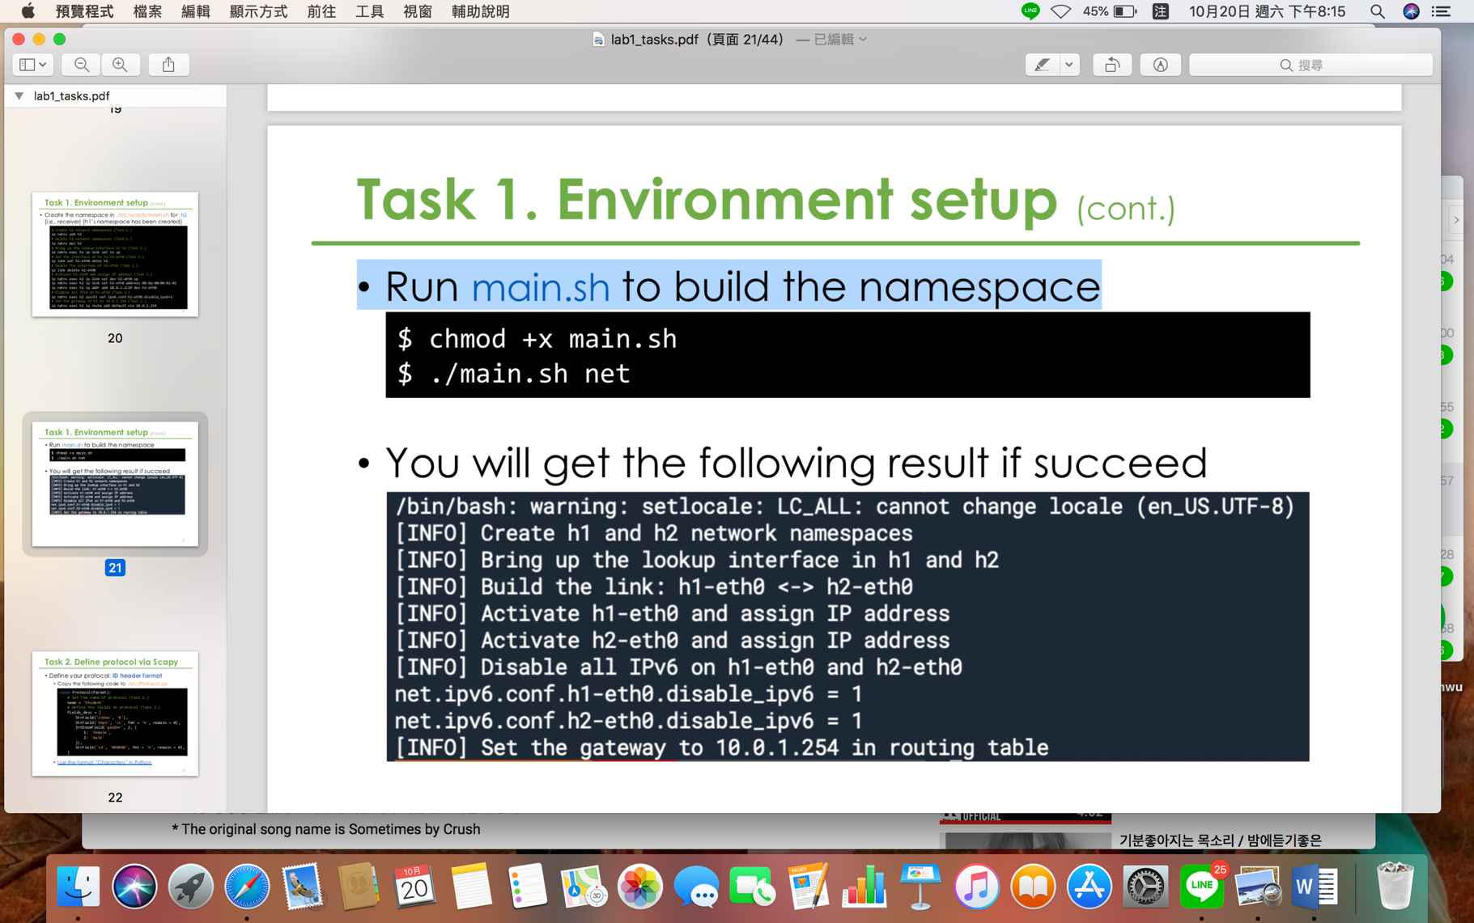

Task 2. Define protocol via Scapy

• Define my protocol: ID header format

• Copy the following code to ./src/Protocol.py

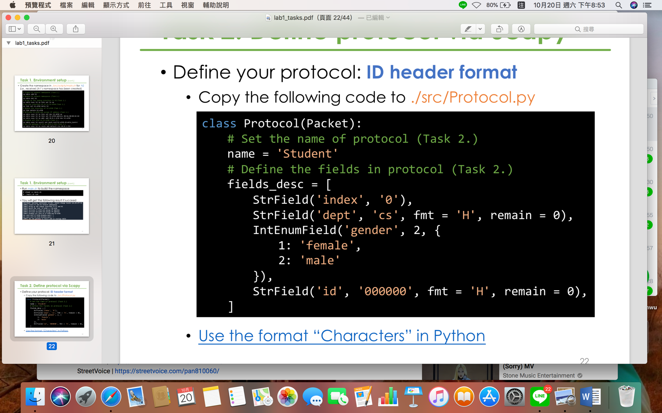

Task 3. Send packets

• Set my own packet header in ./src/sender.py

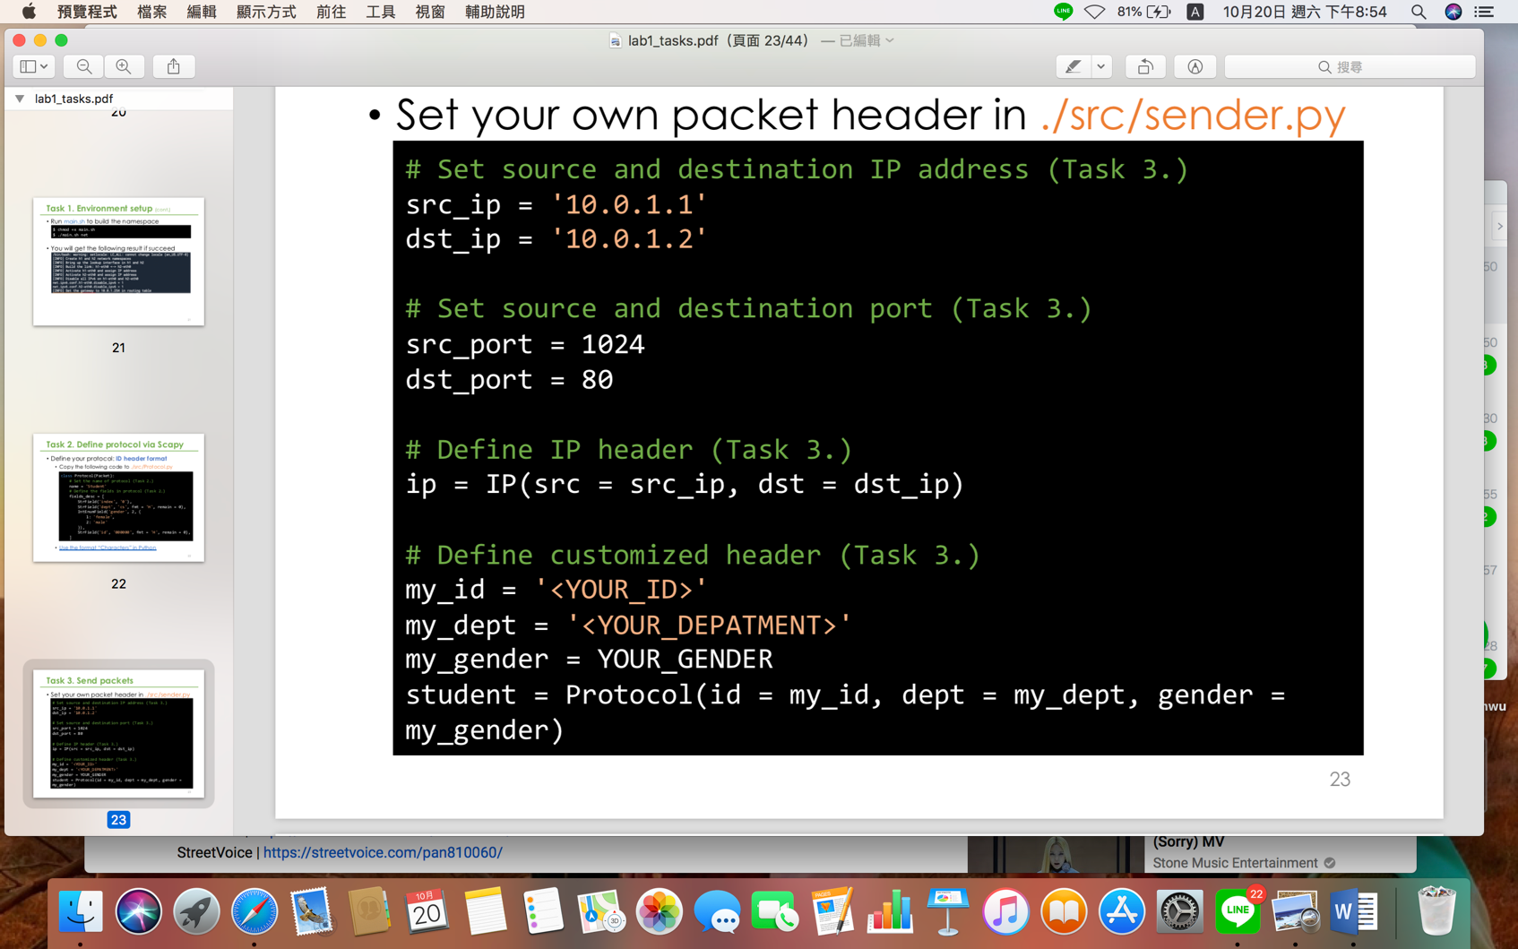

‘<YOUR_ID>’ 🡪 0616039

‘<YOUR_DEPATMENT>’ 🡪 CS

YOUR_GENDER 🡪 1

• Send packets:

Add the codes below in ./src/sender.py

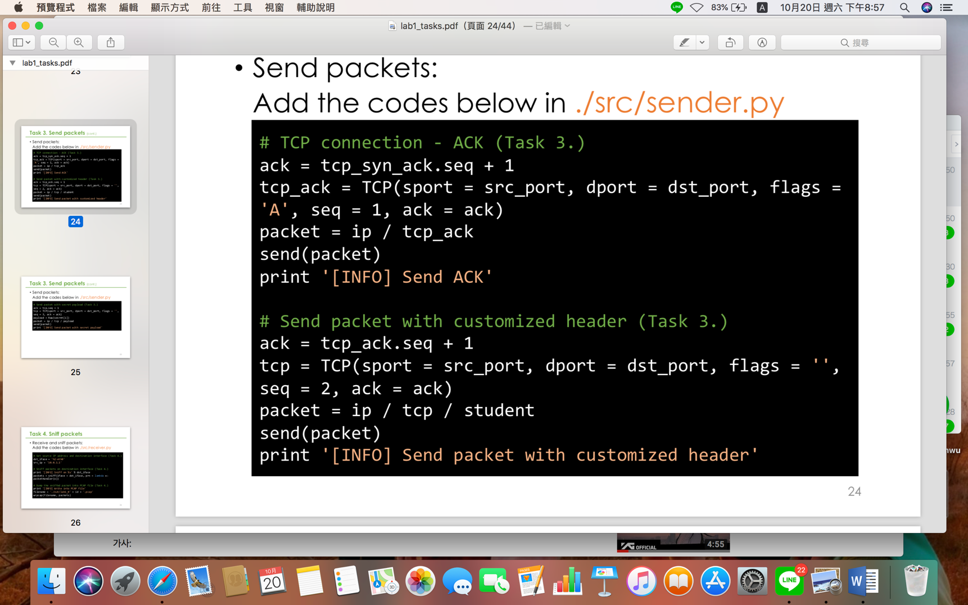

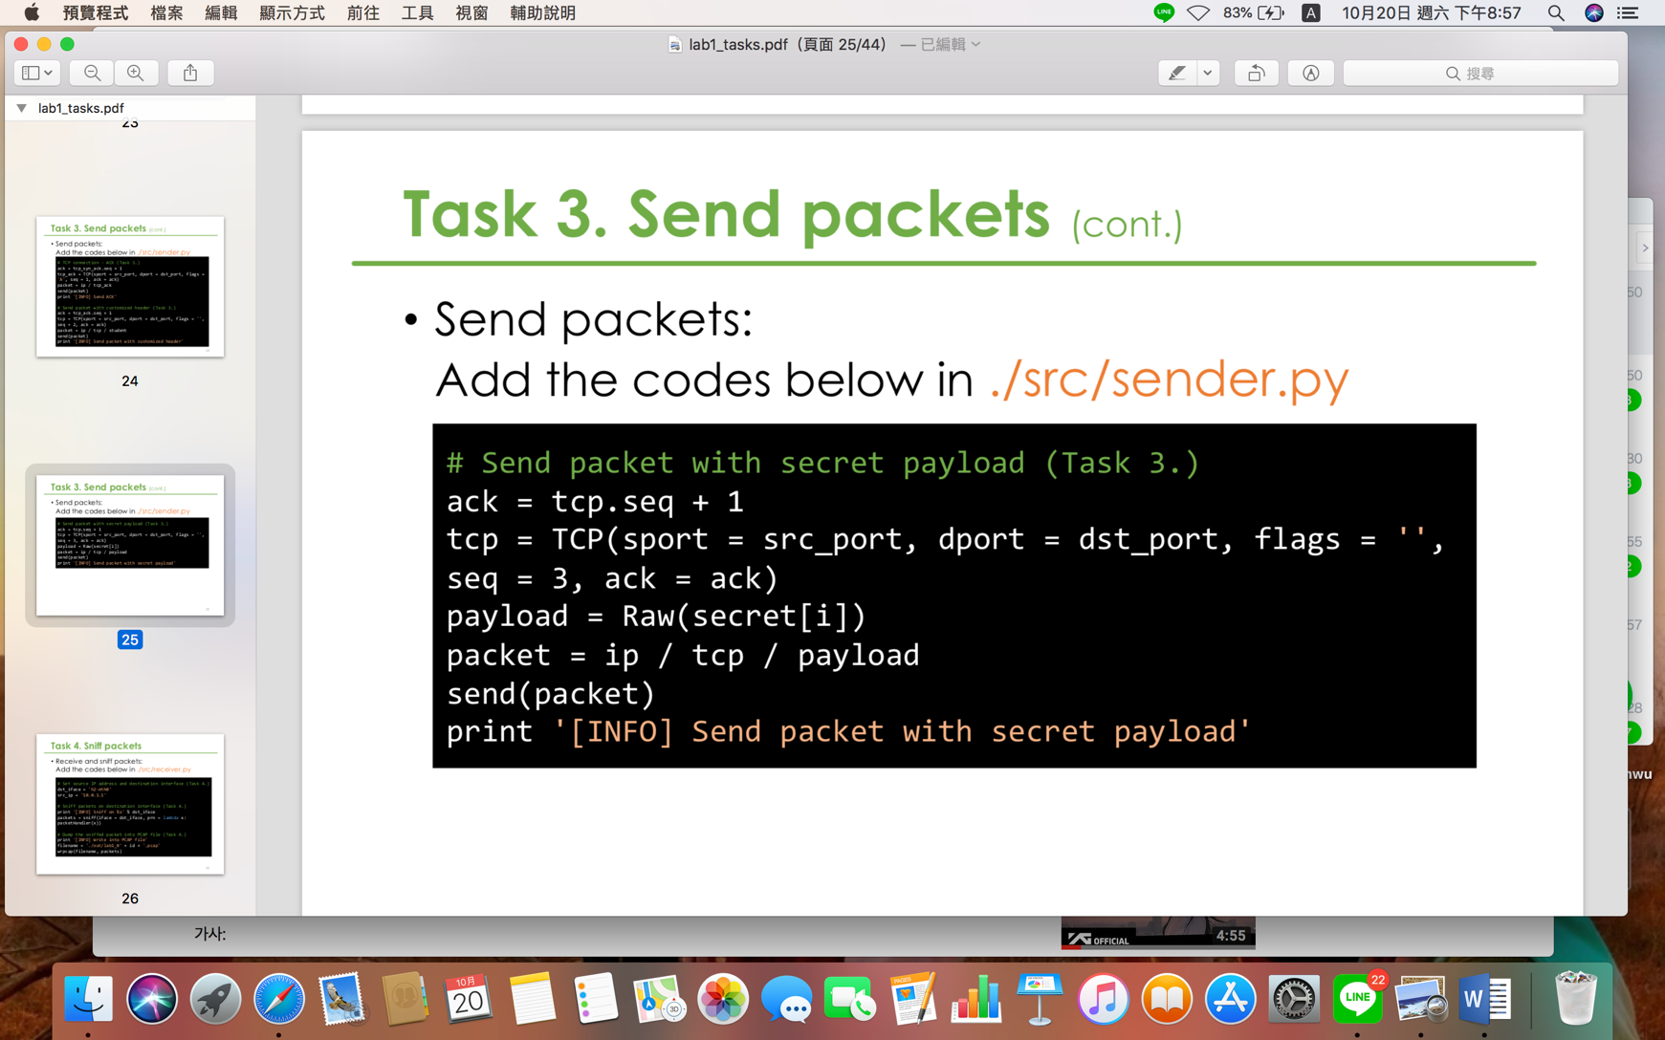

Task 4. Sniff packets

• Receive and sniff packets:

Add the codes below in ./src/receiver.py

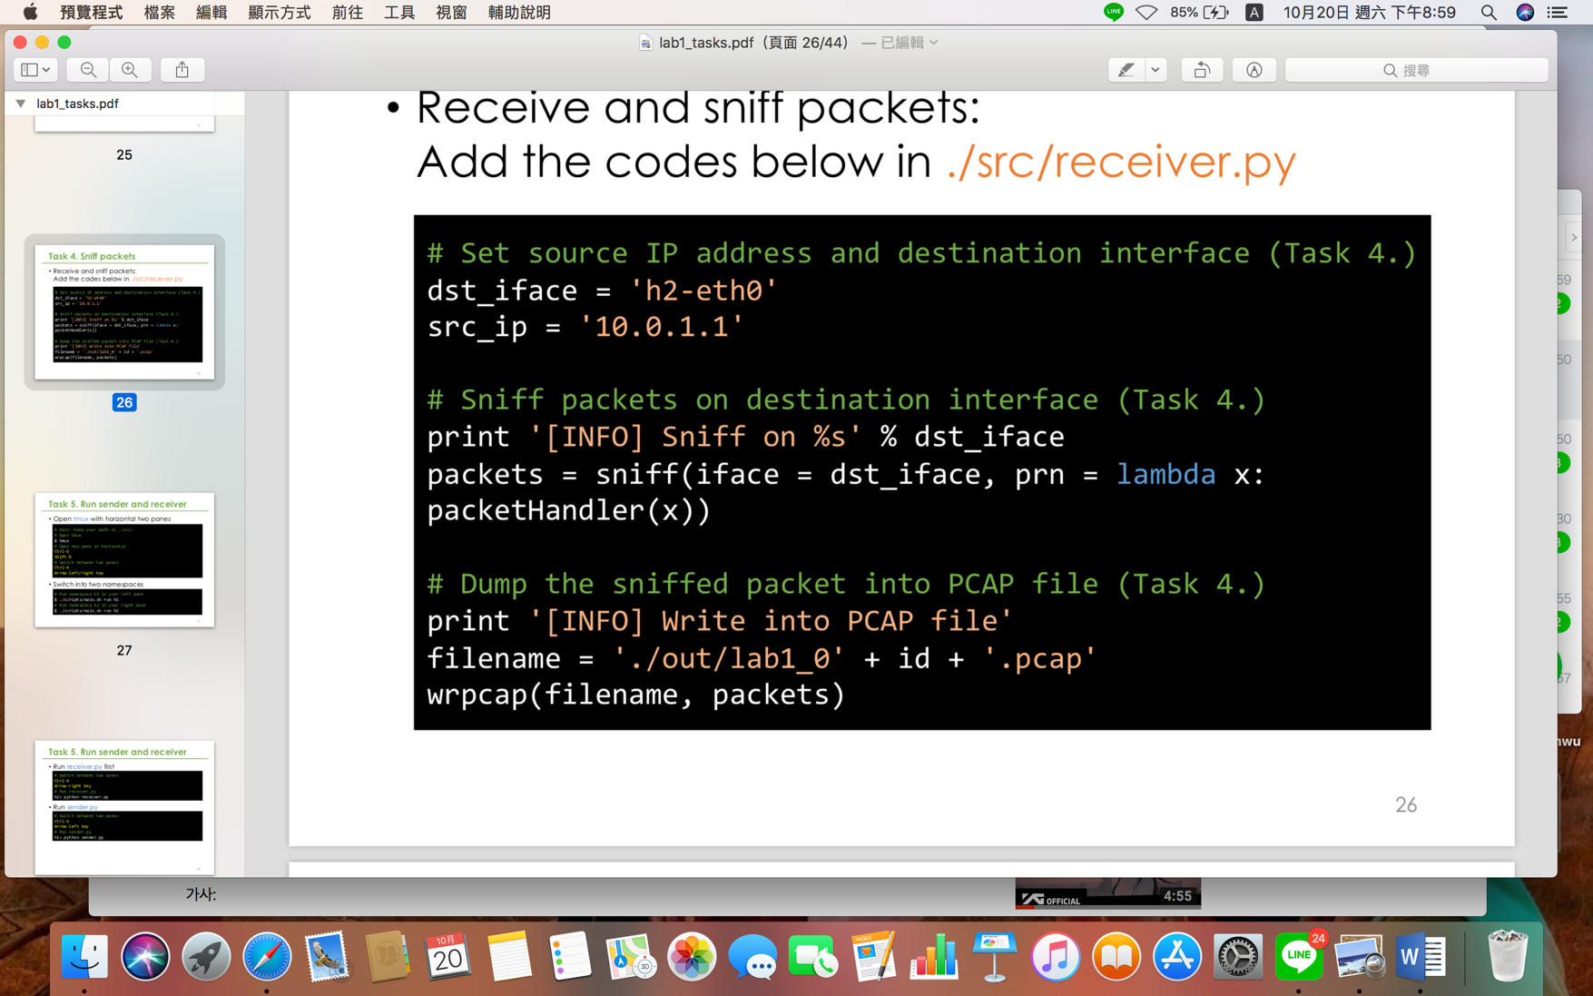

Task 5. Run sender and receiver

• Open tmux with horizontal two panes

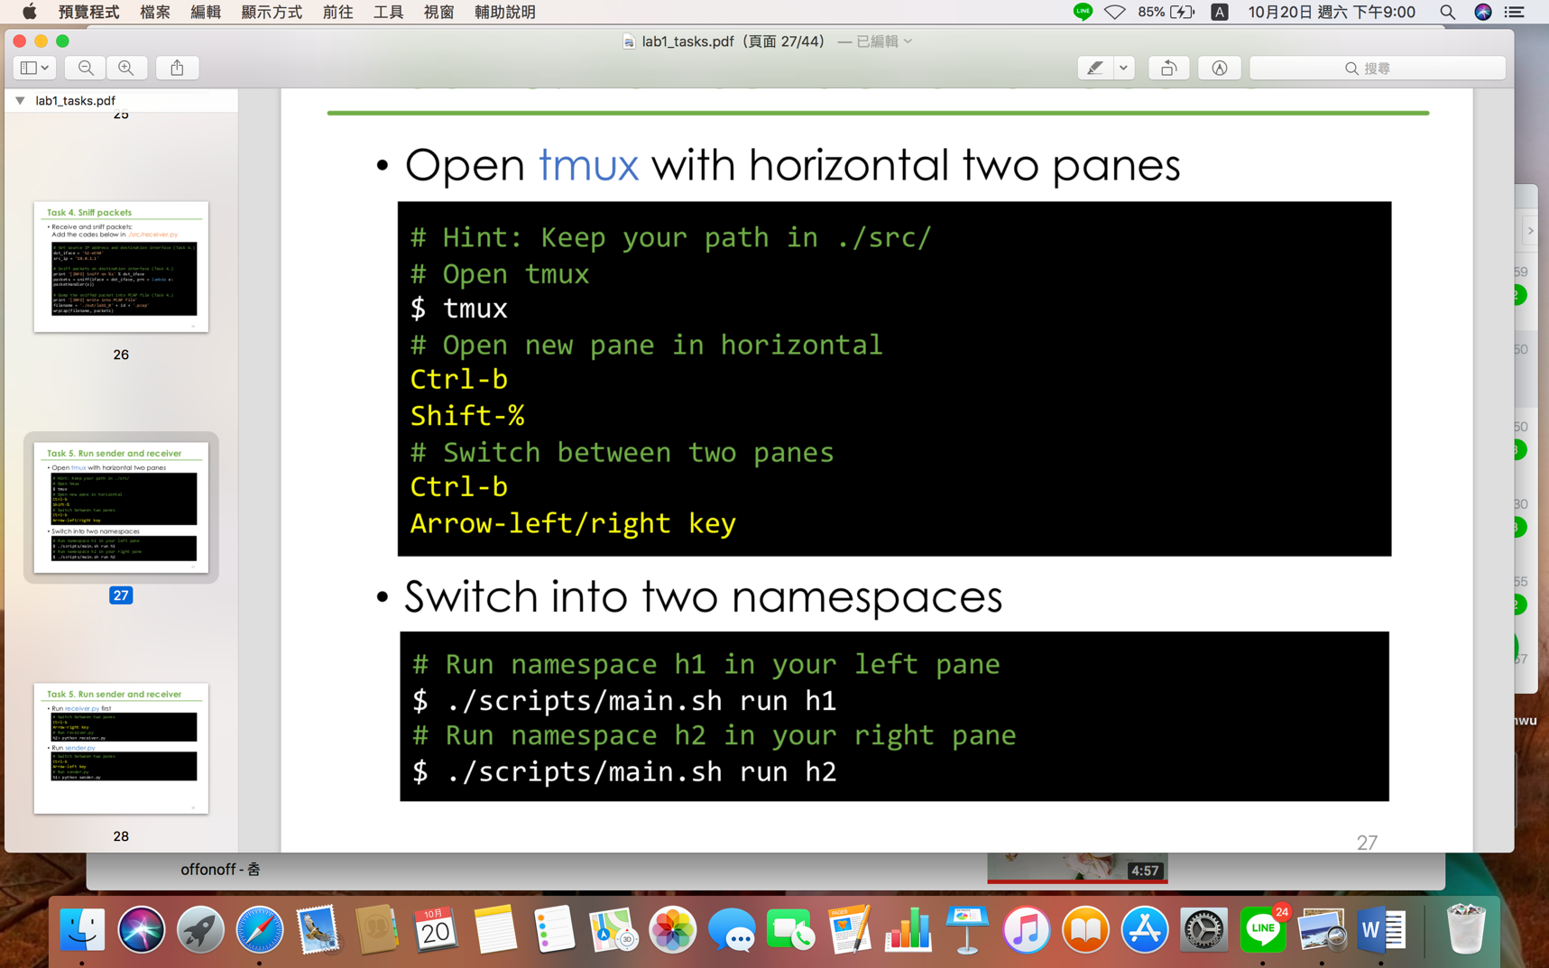

• Switch into two namespaces

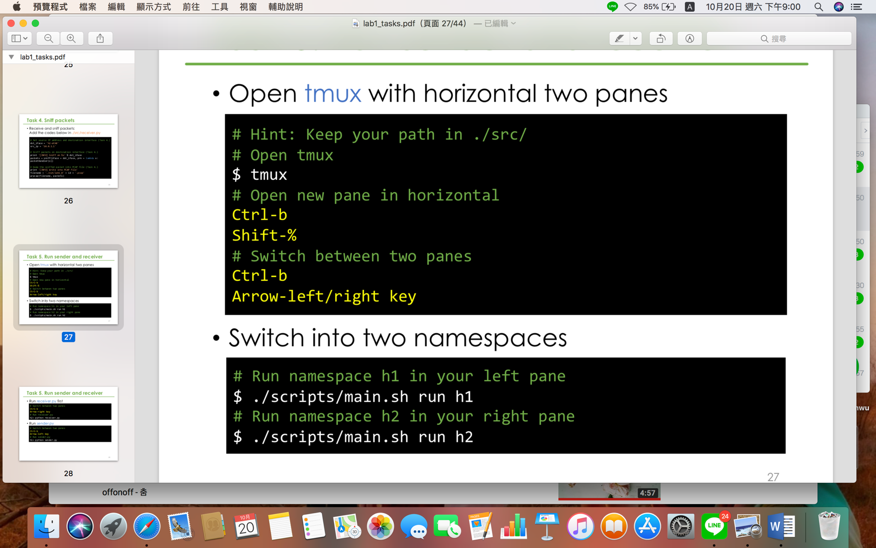

• Run receiver.py first

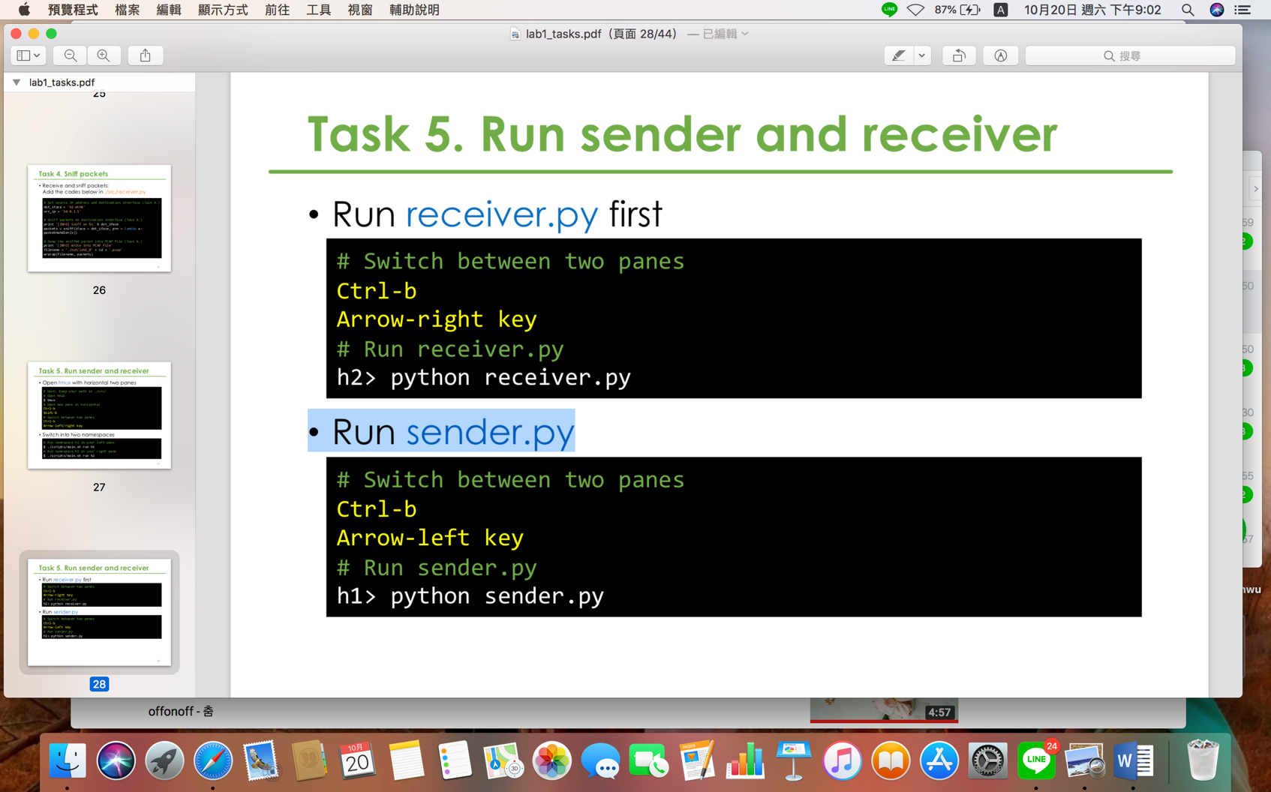

• Run sender.py

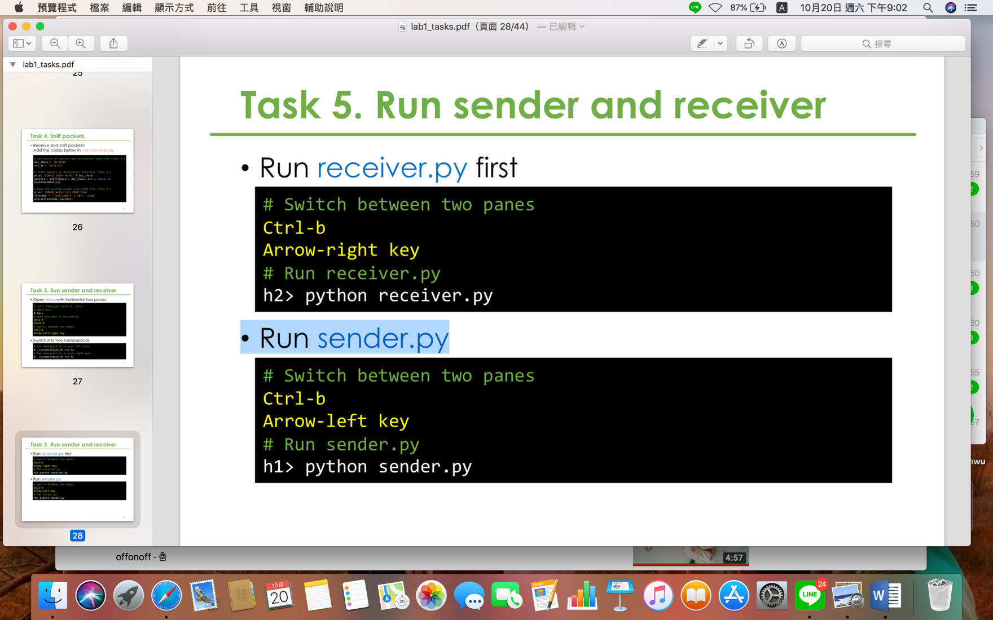

Task 6. Push your files to remote

• Use tcpdump to show my PCAP file

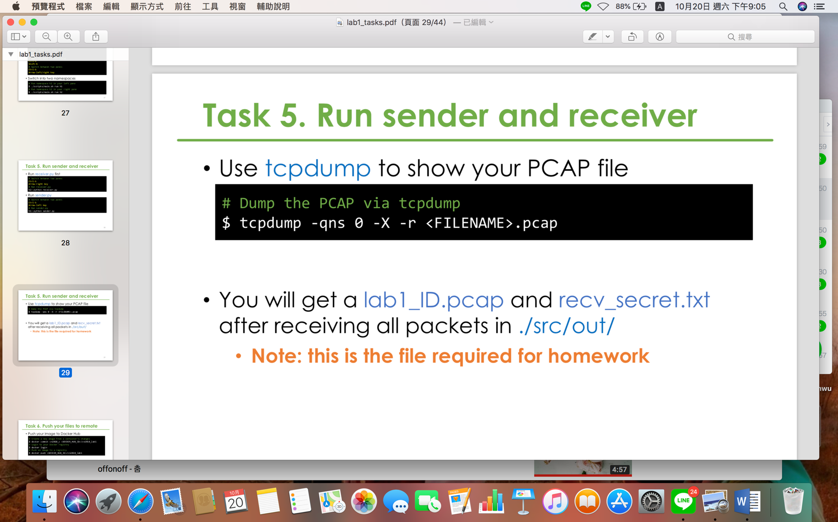

<FILENAME> 🡪 lab1_0616039

• Will get a lab1_ID.pcap and recv_secret.txt after receiving all packets in ./src/out/

• Push my image to Docker Hub

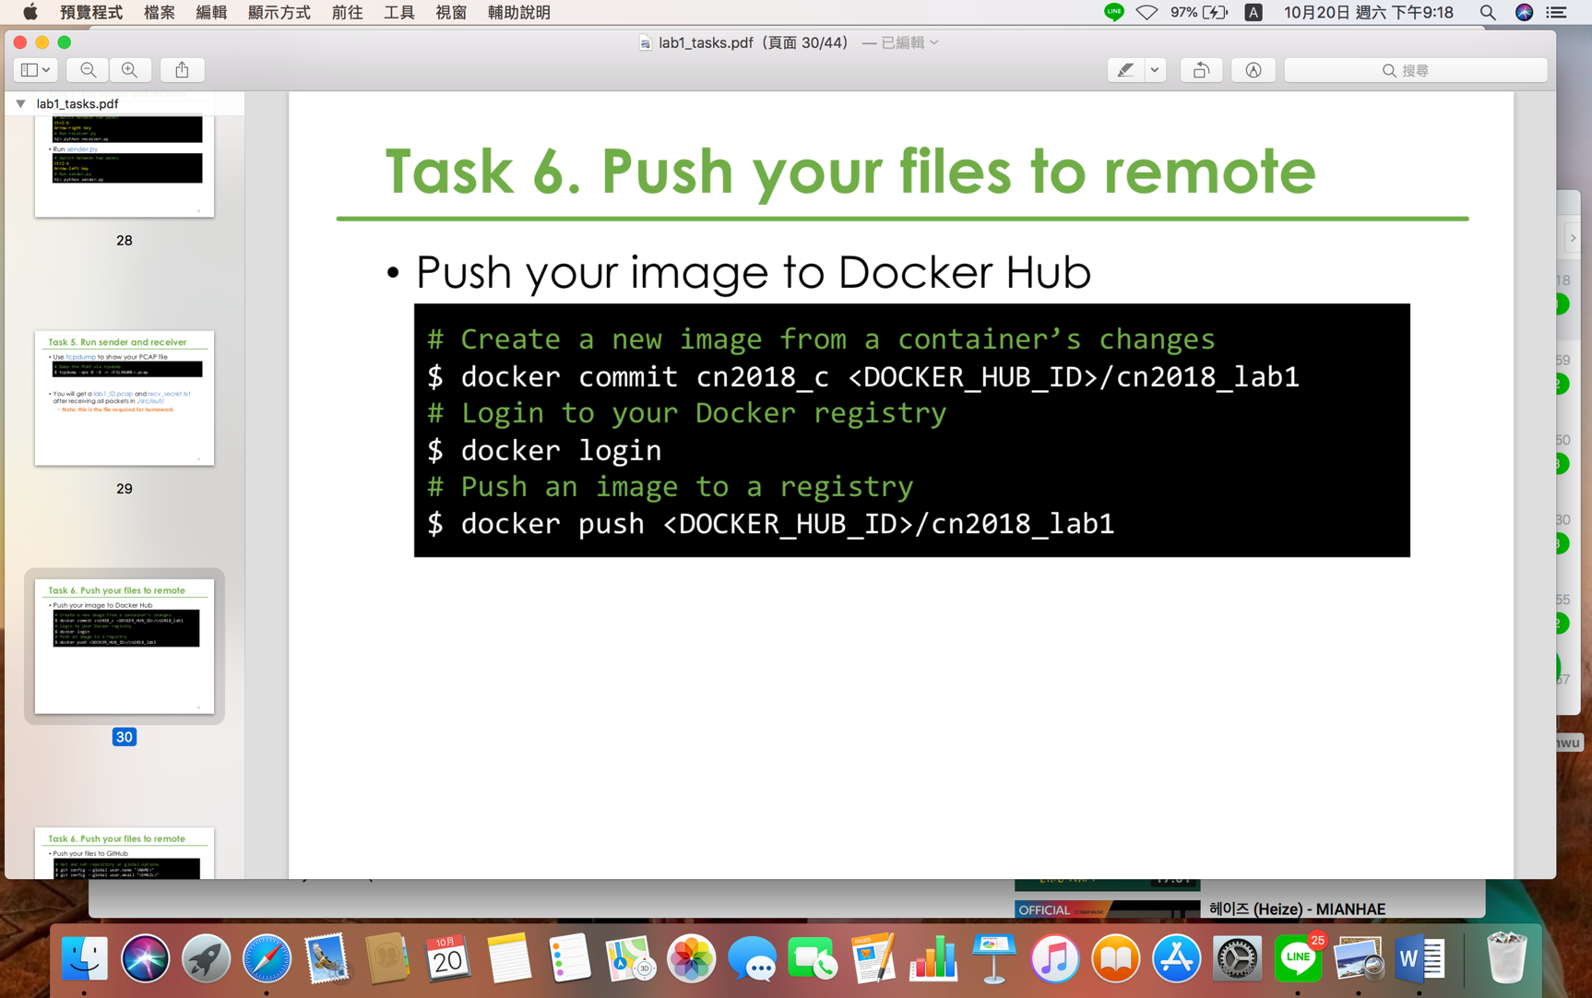

<DOCKER_HUB_ID> 🡪 ivy0621

• Push my files to GitHub

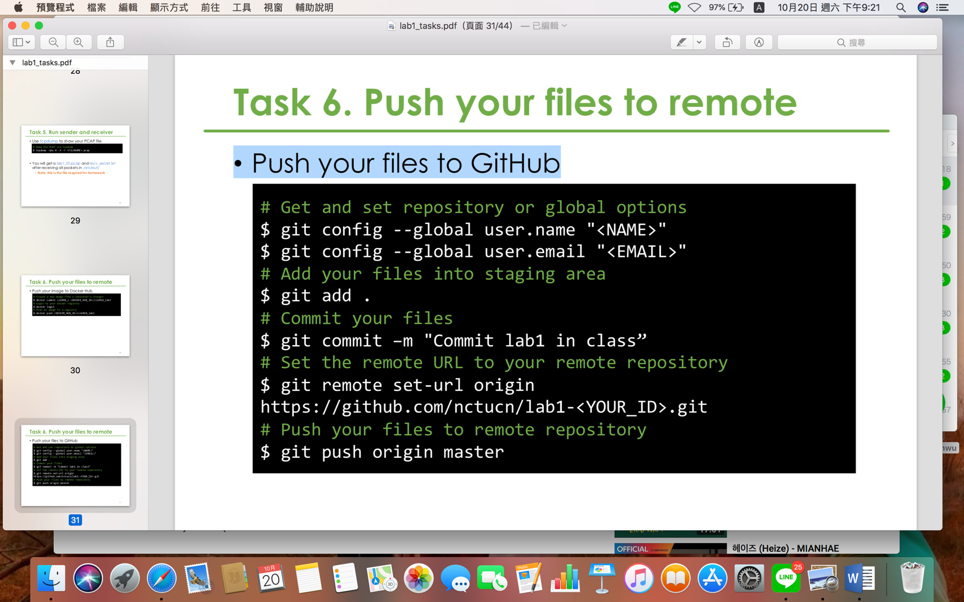

“<NAME>” 🡪 0616039

“<EMAIL>” 🡪 ivy0621.cs06@g2.nctu.edu.tw

<YOUR_ID> 🡪 0616039

Task 7. Load PCAP via Wireshark

• Download my code from GitHub

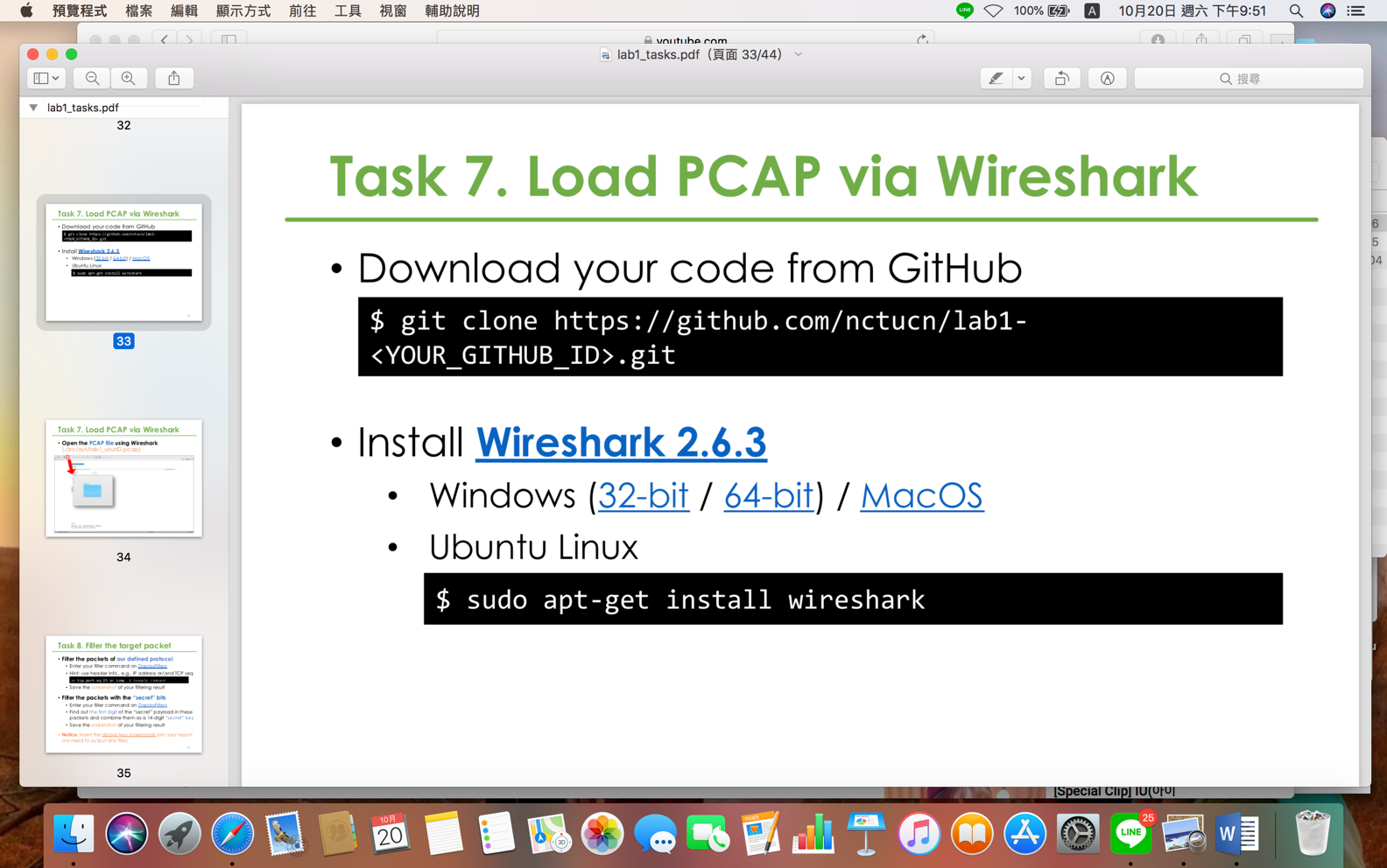

<YOUR_GITHUB_ID> 🡪 0616039

• Open the PCAP file using Wireshark

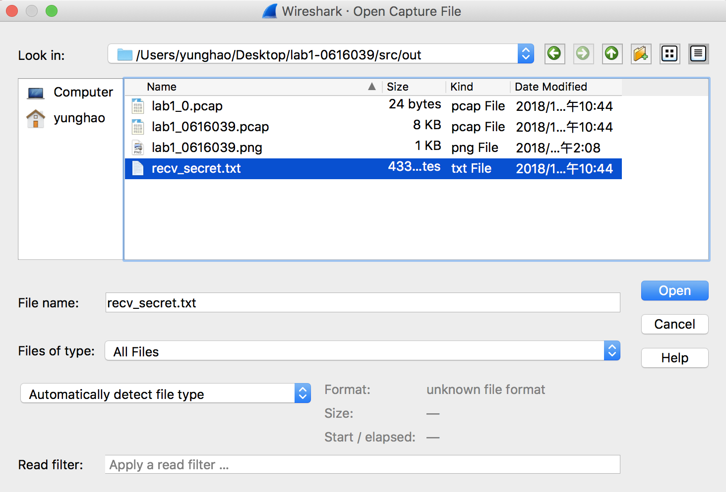

Task 8. Filter the target packet

• Filter the packets of our defined protocol

• Filter the packets with the “secret” bits

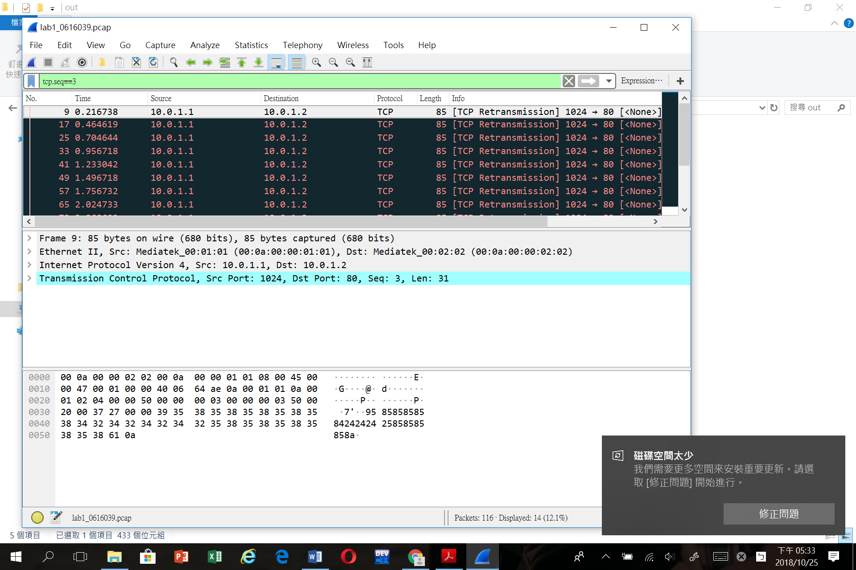

Task 9. Decode the secret key

•Input the secret key into ./src/decoder.py

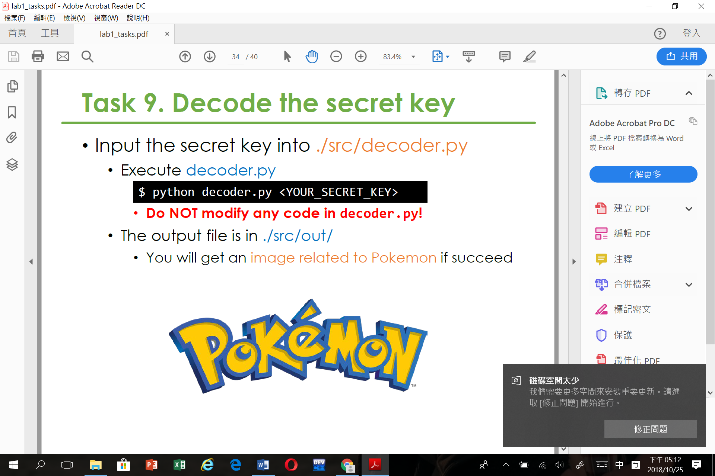

•The output file is in ./src/out/



Bonus

•What you have learned in this lab?

我學到如何傳送資料(sender.py、receiver.py)，也知道如何只擷取某幾個資料，也成功找到我的secret key。

•What difficulty you have met in this lab?

我一開始在課堂上做的時候，在最後一個階段，就是要merge的部分錯了，所以一直錯誤，後來把很多多出來的東西刪掉之後，才成功。